**Practical 5: Create LL(1) parse table for a given CFG and hence simulate LL(1) parsing.**

**Aim**: Using JFLAP create LL(1) parse table for a given CFG and hence Simulate LL(1) parsing

**Implementation: -**

**Step 1.** Choose the grammar from JFLAP and insert grammar you want to create LL(1) parsing table.

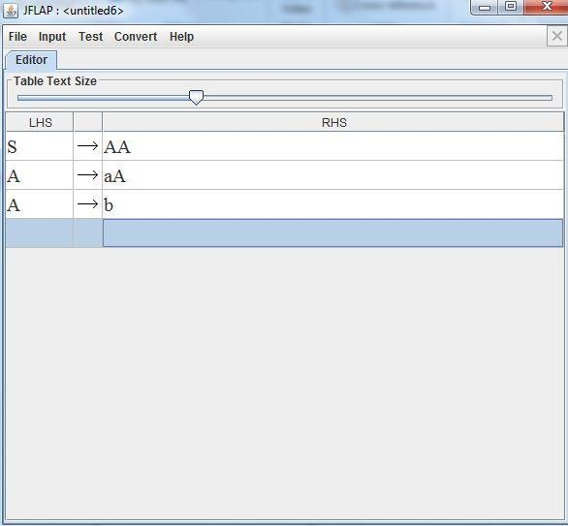

**Step 2: -** Select the Input from Menu and select Build LL(1) parsing table from it.

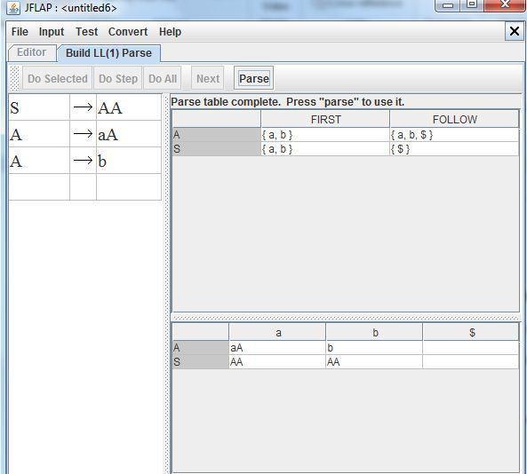

**Step 3: -** Now select parse to use that table to create parse tree from it.

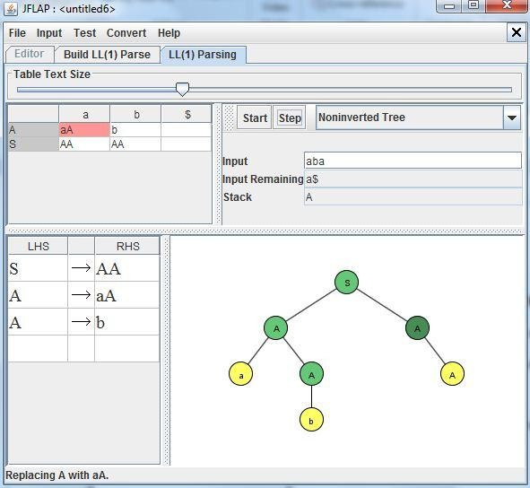

**Result:-** We create LL(1) parse table for a given CFG and hence Simulate LL(1) parsing